Facilitating with Complexity  - Assessment  - Conducted in depth  - Considers: culture, goals, external pressures  - Requires more than meeting with the group's leader  - Convening  - Who are the stakeholders?  - How should they be represented?  - Contracting  - What formal results are expected?  - What informal results are expected?  - What resources and energy need to be committed to achieve this?  - Process design  - Determine techniques  - Determine activities  - The process is fluid not static  - Conducting the session  - Follow the broad process - open, build understanding, achieve the task, close  - Consider the meeting through each of the groups capacities - physical, emotional, intellectual, intuitive, creative, spiritual  Divergent Thinking  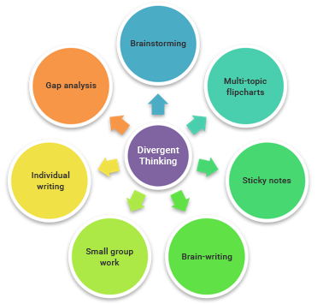 | Group Capacities  In challenging circumstances draw on the capacity of the group:  Physical  Participants will contribute most when their physical needs are accommodated. The facilitator needs to be aware of the mental and emotional state of participants and act accordingly to keep energy levels up.  Emotional  The facilitator should welcome strong emotions and know how to channel them. Ideally participants can express and relieve their emotional tension. The facilitator assists others to understand the reasons for those emotions and accept them.  Intellectual  Being able to solve problems, make decisions and handle technically complex information and deal with competing interests.  Intuitive  The facilitator uses creative modes of interaction which allows participants to access their intuitive and creative sides.  Spiritual  The facilitator establishes conditions which allow participants to transcend self-interests and consider the greater good.
Techniques for converging thinking  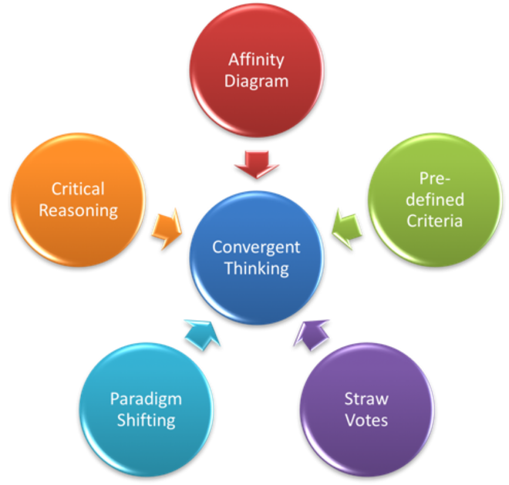  Decision Making Rules  - Delegation  - Unanimous agreement  - Person in charge  - Majority vote  - Algorithm  Mutual Learning Core Values  - Transparency  - Share all relevant information  - Explain why you are saying something  - Explain why you are asking  - Curiosity  - Ask questions you don’t know the answers to  - Allow others to question your ideas  - Take an interest in what others think and say  - Informed Choice  - Maximise decisions based on relevant information  - Accountability  - Explain your reasoning  - Compassion  - Is the emotional glue that holds the core values together | Facilitating Strategic Planning  - Review of mission, vision and values  - Is this still who we are and what we do and are these still the principles that guide us?  - SWOT analysis  - What are the Strengths of the organization?  - What are the Weaknesses of the organisation?  - What are Opportunities we can exploit?  - What are the Threats to the organisation?  - Review prior strategic commitments and accomplishments  - What did we say we would do?  - What did we actually do?  - Were the strategies appropriate? Did they get us closer to our goals?  Facilitating Process Improvement  - Construct a process map  - Brainstorm all activities that routinely occur within the scope of the process  - Group the activities into 4-6 key sub-processes  - Identify the sequence of events and links between the sub-processes  - Define as a high-level process map and sub-process maps using ICOR  - Force Field Analysis  - Cause and Effect Diagram

