Teams with high potential for synergy  - Focus on shared interests and goals  - Share recognition with team members  - Share accountability and leadership. Skills and contributions are honoured by others  - Create an atmosphere of mutual trust and understanding  - Do not focus on assessing blame and credit  - Respect and include all team members  - Have members that ask “How can I best contribute to the team?”  - Value and accept diversity and see it as an important resource  Creating and environment for synergy  High functioning synergistic teams have the following characteristics:  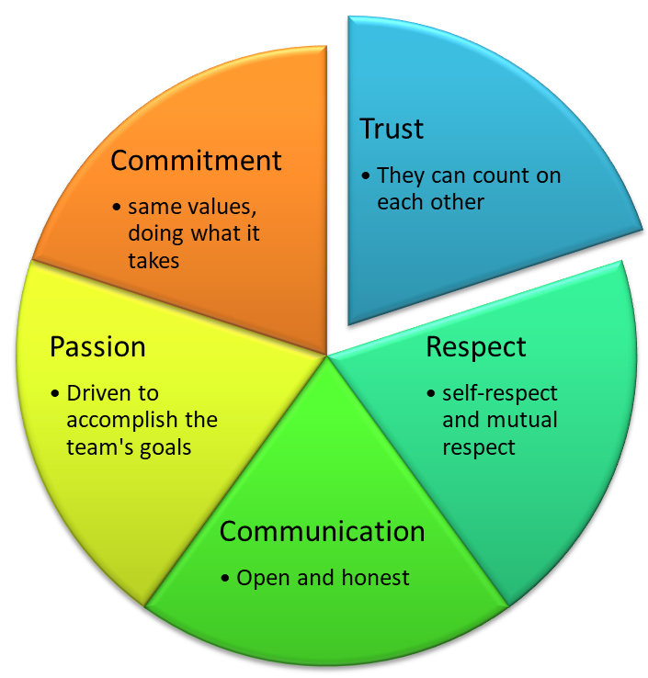 | Capacity for Trust  Capacity for trust in a team is built in four domains.  Trust of Capability  Acknowledge people's abilities and skills  Allow people to make decisions  Involve others and seek their input  Help people learn skills  Trust of Character  Manage expectations  Establish boundaries  Delegate appropriately  Keep agreements  Be consistent  Trust of Communication  Share information  Tell the truth  Admit mistakes  Give and receive constructive feedback  Maintain confidentiality  Speak with good purpose  Trust of Caring  Show empathy  Share the risks  Unite in the face of challenges  Show utmost respect

Enabling conditions for high performing teams  Compelling Direction  - Explicit goals  - Challenging goals (to enable a ‘flow’ state) but not impossible  - Team members need to care about the goals – a mix of extrinsic and intrinsic reward  - Pay  - Recognition  - Satisfaction  - Making a meaningful contribution  Strong Structure  - Balance of skills amongst members  - Diversity in knowledge, views and perspectives  - Diversity in age, gender and cultural background  - Establish clear norms  Supportive Context  - Reinforcing good performance  - Real time access to data and information  - Sufficient resources  Shared Mindset  - A counter to ‘us vs them’ is having a shared mindset  - Move towards a shared understanding and a common identity  • Shared knowledge is the cornerstone of collaboration | Using Team Strengths  Each of us can describe those times when we are at our best, when time loses meaning because we are so engrossed in what we are doing and in a euphoric state. It is during these moments that we are deploying our strengths somewhat effortlessly. It is during these times that we maximise our productivity and the quality of what we are doing. Each of us has different strengths. The secret to team synergy is recognising the unique contribution that each person makes to the team and then using that contribution to best effect  4D Teams  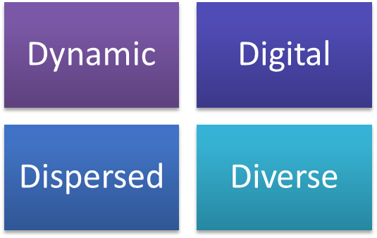  Digital – the increasing use of technology in different ways. Digital dependence. Digital communication.  Dispersed – team members working different hours and from different locations. Collaborating with others in different time zones  Diverse – generational, educational, cultural, experiential  Dynamic – frequent changes in team membership. Teams being formed at short notice. Teams needing to be agile to cope with rapidly changing business conditions

