5 Habits of Highly Effective Communicators  Mind the say-do gap  This is all about trust. Your behaviour is your single greatest mode of communication and it must be congruent with what you say.  Make the complex simple  We are bombarded 24/7 with information which can make it hard for you to be heard. Effective communicators distill complex thought and strategies into simple and memorable terms that can be acted upon.  Find your own voice  Use language that's distinctly your own. Let your values come through in your communication. Concentrate on being distinct and real. People want real. People respect real. People follow real. Be genuine, and people will respect you for it.  Be visible  E-communication serves a valuable purpose however it is no substitute for face-to-face and voice-to-voice communication. Visibility is about letting others get a feel for who you are and what you care about.  Listen with your eyes as well as your ears  Stop, look and listen. Effective communication is two-way. Good communicators know how to ask good questions and then listen with both their eyes and ears. You need to read between the lines.  Questioning Techniques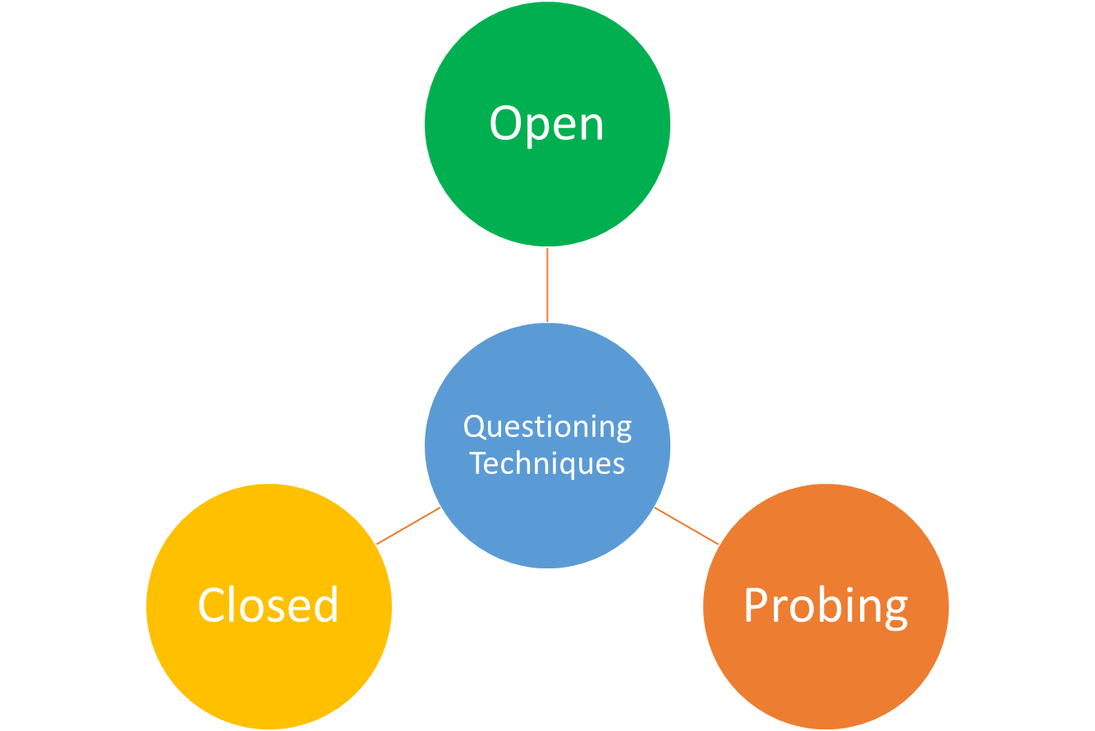  Personal Style Interactions  Understanding your personality style and communication preferences, provides you with the knowledge of how to communicate more effectively in diverse situations and with a variety of people 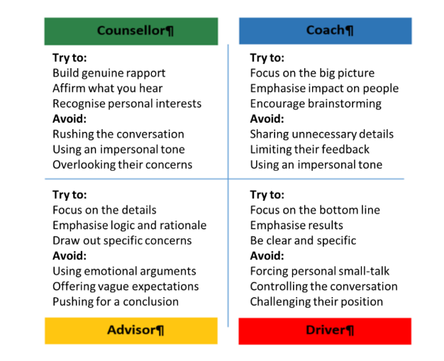 | Barriers to Listening  Speaking Like a STAR  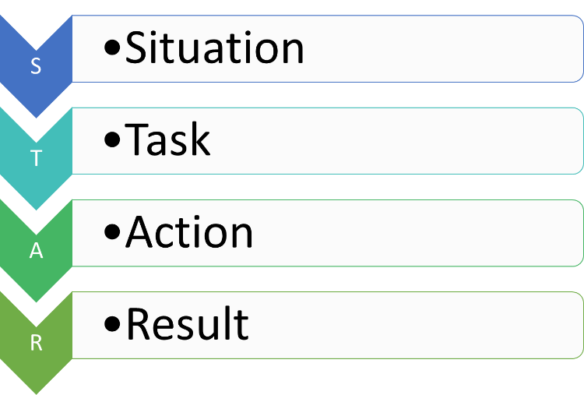  Using I Messages  Ladder of Inference  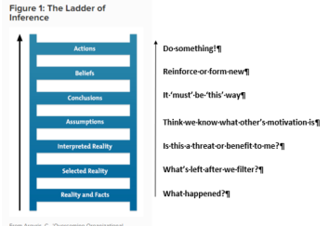  All About Body Language
Communication Barrier | Understanding the Barrier

