The ‘Challenger’ Sales Role  - Has a different view (possibly to the buyer) on how things work  - Loves to debate  - Pushes the buyer and understands the business  Target Agile Organisations  - Organisational Basics  Does the buyer have significant current or potential spend?  Is the buyer financially sound?  - Operating Environment  Does the buyer face external pressures to change, such as new industry regulations or loss of market position?  Are there internal pressures to change, such as new management or a rethinking of strategic direction?  - View of the status quo  Is there organisation-wide discontent with the status quo?  Does the current supplier fall short of expectations?  Is the buyer unhappy with existing workarounds?  - Receptivity to new or disruptive ideas  Do internal stakeholders frequently share best practices?  Do they attend conferences and other learning events?  Do leaders look to the broader organisation for ideas?  - Potential for emerging needs  Do stakeholders engage in constructive dialogue when their assumptions are challenged?  Do they seek to continue conversations about industry benchmarks and trends?  Is there at least one confirmed “mobiliser” in the company? | Difference Between Solution and Insight Selling  Solution Selling Insight Selling  What kind of company to target Organisations that have a clear vision and established demands Agile organisations that have emerging demands or are in a state of flux  What sort of information to gather What need is the buyer seeking to address? What unrecognised need does the buyer have?  When to engage After the buyer has identified a problem the supplier can solve Before the buyer has pinpointed a problem  How to begin the conversation Ask questions about the buyer’s need and look for a “hook” for your solution Offer provocative insights about what the buyer should do  How to direct the flow of information Ask questions so that the buyer can steer you through its purchasing process Coach the buyer about how to buy, and support it throughout the process  Target Mobilisers Buyer Types  Go-Getter  - Motivated by organisational improvement  - Constantly looking for good ideas  - Will champion great insights  Teacher  - Passionate about sharing insights  - Are sought out by colleagues for their input  - Good at persuading others  Sceptic  - Push back on most things  - Wary of complicated projects  - Proceed cautiously
Areas where salespeople make the biggest impact on buyers  - Offering unique / valuable perspectives on the market  - Helping the buyer navigate alternatives  - Providing ongoing advice and consultation  - Helping the buyer avoid potential landmines  - Educating the buyer on new issues / outcomes  - Ensuring the supplier is easy to buy from  - Ensuring the supplier has widespread support across the organisation  The Teaching Pitch  The Warmer  - Build credibility and show your prospect you understand their challenges. This serves as the introduction for the pitch.  The Reframe  - Connect those challenges to a bigger problem or opportunity they hadn’t previously considered. Build credibility and show your prospect you understand their challenges. This serves as the introduction for the pitch.  Rational Drowning  - Next, show prospects the numbers behind why they should think differently.  Emotional Impact  - Then, create an emotional connection between the pain in the story you’re telling and the pain they feel every day in their organisation.  A New Way  - It’s time to convince them of the solution. Show them the new way they should be thinking about their business.  Your Solution  - Finally, demonstrate how your solution is the best one out there, and how it fits with the new way a prospect should be thinking about their business. | Insight Selling Behaviours  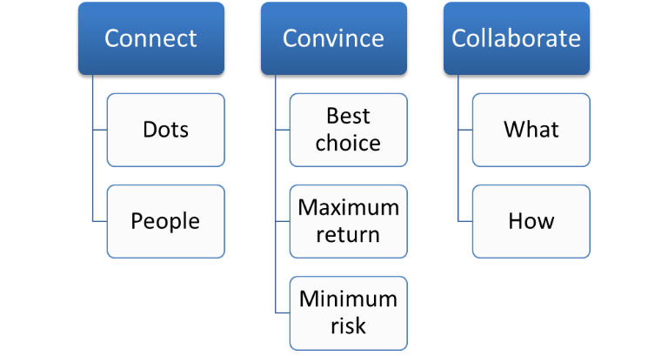  Minimise the Perception of Risk for the Buyer  The buyer must be thinking the salesperson:  - Was professional  - Depicted the purchase process accurately  - Was trustworthy  - Inspired confidence in his or her company  - Helped me avoid potential pitfalls  - Was respected at my organisation  - Had experience in the specific areas I have needs in and also in my industry  Ways to Educate your Buyer

The Seller as a Collaborator  Prepare buyers to collaborate  - Set up a meeting with the context of getting input from the buyer into your ideas. Set the meeting off inviting them to share their thoughts  Wonder with the buyer  - Engage the buyer in wondering with you about the possibilities they might envisage from implementing a particular solution  Ask incisive questions  - Ask meaningful questions that forces the buyer to think, that gets the buyer out of their comfort zone and that gets to the heart of the issue  Shape the path forward - together  - Shape the solution with the buyer's input. This will increase both their ownership and commitment. Show absolute respect for the buyer's involvement  Give the buyer ownership of the idea  - When the buyer owns the concept, it increases their desire to see it through and therefore sign off on it | Use Persuasive Tactics  Reciprocity - People feel obliged to give back to others the form of a behaviour, service or gift they received first. Reciprocity increases if what was given in the first place was both personalised and unexpected.  Scarcity - People have a greater desire for things that are scarce. From a sales perspective, point out what is unique about your proposition and want the potential buyer stands to lose for failing to accept your proposal.  Authority - People follow the lead of credible, knowledgeable people. It is important to signal to buyers what makes you and your brand credible and what level of expertise you bring to the sale.  Consistency - Personal consistency is highly valued in most cultures. Consistency is activated by small initial commitments that can be made.  Liking - People prefer to buy from people they like. We like people who are similar to us, people that pay us compliments and people that cooperate with us towards mutual goals.  Consensus - When people are uncertain that can be persuaded by the actions of others to determine their own behaviour. Sellers can use this to point out that other similar customers have bought their product or service.

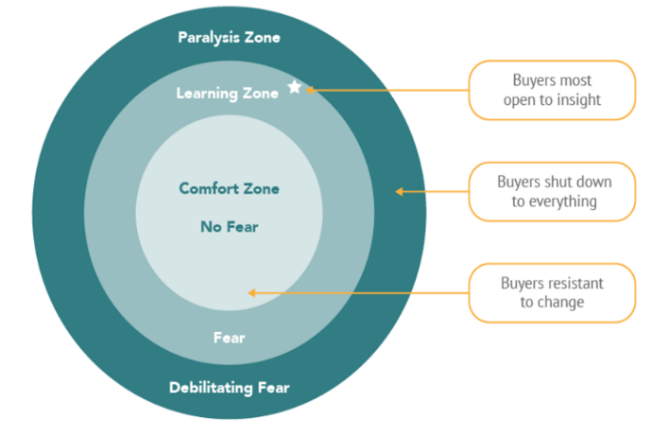
Cognitive Reframing

Disrupt

Disrupt buyer thinking by providing
new ideas, asking questions advocating alternatives

Reframe

Reframe the discussion around this
new thinking

Direct
Direct the buyer to new and better possibilities

