Effective Communicator Needs  - Knowledge  - Skills  - Attitude  People will forget what you said. They will forget what you did. But they will never forget how you made them feel. Maya Angelou  Seven Deadly Sins  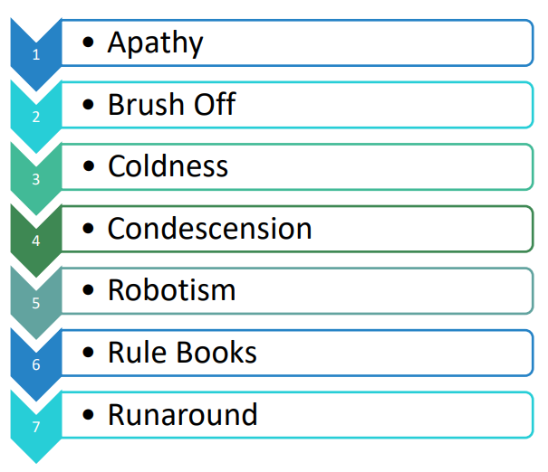  The ABCDE (Five Qualities) of a Good Telephone Voice  - Alertness - Your voice must have spark and energy.  - Balanced - Your voice should be soft, happy, in a pleasant mood.  - Conversational tone – Be a human being talking with-not at- another human being.  - Distinctness – Clearly articulate each word and show that you are seeking understanding.  - Expressiveness – Vary the tone and pace of your voice to suit the situation. | Your Welcome – Should HAIL  Use HAIL technique to allow your listeners to hear and digest what you are saying.  H = Honesty (straight and clear)  A = Authenticity (be yourself)  I = Integrity (be trustworthy)  L = Love (wish people well)  6 P’s to Para Verbal Communication  Practice voice modulation to help you get the right speed, tone and clarity in your speech.  P = Pace (how fast/slow)  P = Projection (how loud/soft)  P = Pitch (how high/low)  P = Pause (convey shades of meaning)  P = Pronunciation (articulate each word fully)  P = Positivity (wear a smile at all times)  Create a Positive First Impression  - Answer promptly – before 3rd ring.  - Be prepared – stop what you are doing, smile, take a breath and focus.  - Introduce yourself.  - Use their name as soon as possible.  - Use 6P’s to Para verbal communication.  - Be an ‘Active’ Listener.  - Know when to ask for help – remember you don’t need to know everything. You need to know who can help.  - Thank them for calling. Breathe from your diaphragm
4 Key Parts to your Phone Greeting  - Salutation – Good Morning  - Company Name  - Your Name  - Offer of Assistance  E.g. Good Morning, PD Training this is Stacey, how can I assist you today?  Show Urgency  Everyone is busy and want things done immediately. Let your caller know you will manage their enquiry with a sense of urgency.  - Express Urgency – rest assured that this will be done ….  - Quote facts for postponement of resolution  - Promise results soon  - Apologize for the inconvenience  - Keep the customer informed about the proceedings  Use a phrase like:  “Apologies there has been a delay. Let me investigate right now for you and determine what we can do.”  Ending a Call Politely and Professionally  - End the call on a high note – make them feel welcomed to call you again.  - Summarize – Before you go, let me summarize…  - Add Value – ‘one tip I love to provide…’  - Thank the client for calling – it is essential to make the client feel cherished and important.  - Wafflers – switch to the past tense. E.g. ‘I appreciate the time you have spent in explaining the situation to me’ | 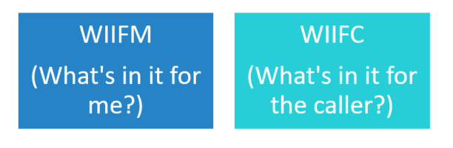  Good Questioning Techniques  - Open Questions help you:  - Achieve an elaborate answer  - Receive an explanation or clarification  - Get the respondent to think and reflect  - To receive opinions and answers  - Give the respondent control  E.g. What, how, why, where  - Closed Questions are used when you want:  - To receive/confirm facts  - A quick answer  - To keep control of conversation  - A one-word response  - To keep it easy for the respondent as they don’t need to reveal too much  E.g. Do, are, Have, Can Should  - Clarifying Questions - e.g. “and you need an answer by Friday?”  - Seek Satisfaction/Understanding – e.g. “Are you okay with the suggestion I made?”  Use the HEAT to Defuse an Irate Client  H = Hear them out!  E = Empathize  A = Ask questions  T = Take responsibility and thank them

